Information book



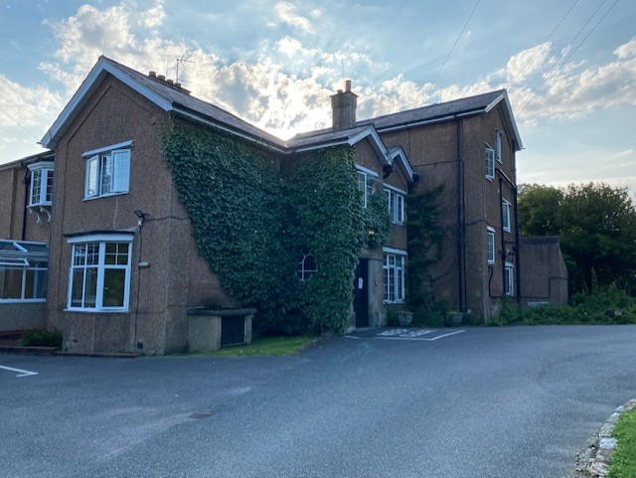

This is Tinkers hatch main house



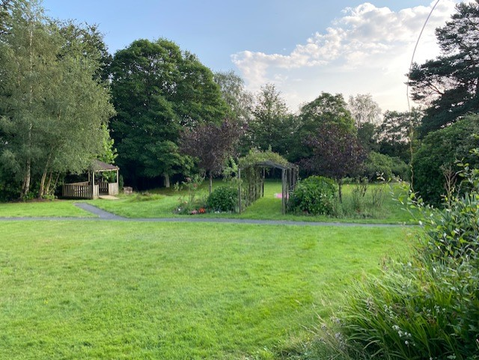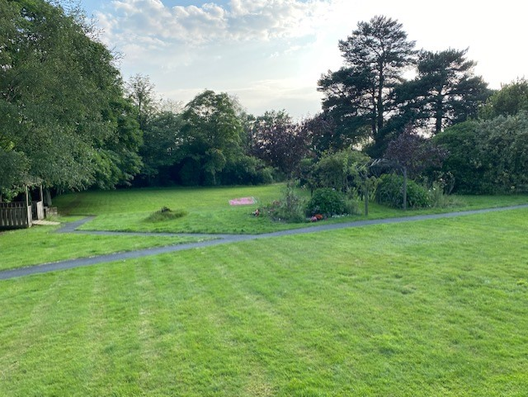

Tinkers has lovely big gardens to explore and help look after.

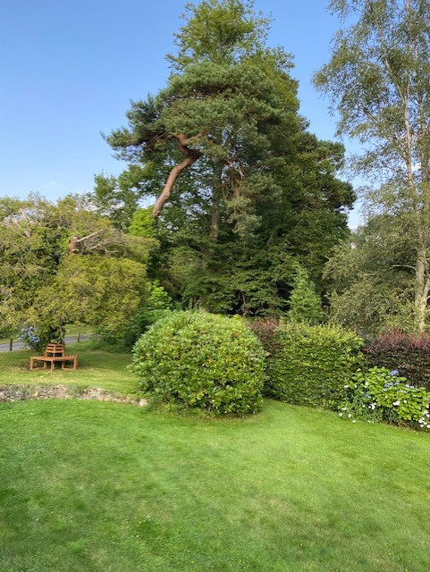 

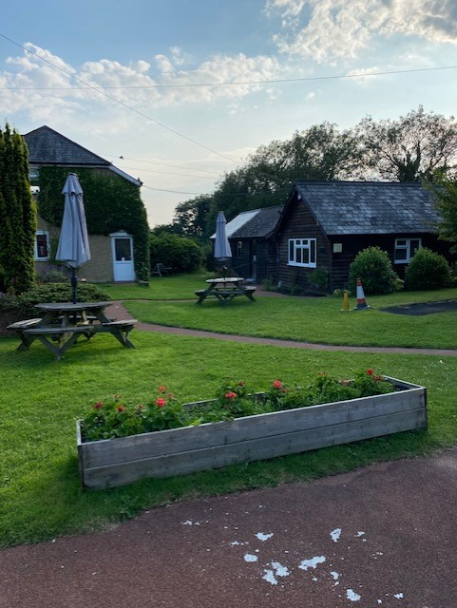



The lounge is a lovely area and was designed by the clients who live and stay here. They wanted calm colours and to bring the outside in.

This is our IT area where you can use the computer.

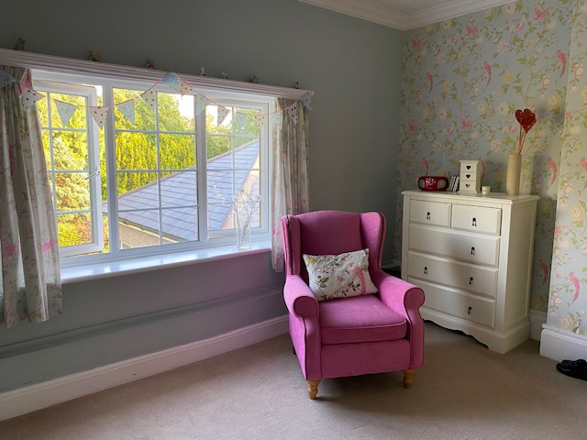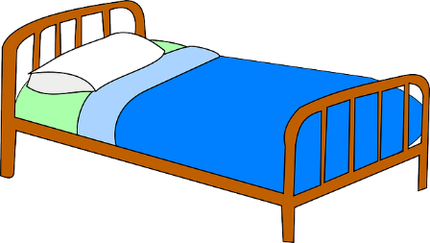

Here are some of our bedrooms they are all very personal to the individual and colours and designs are chosen by the people whose bedrooms they are.

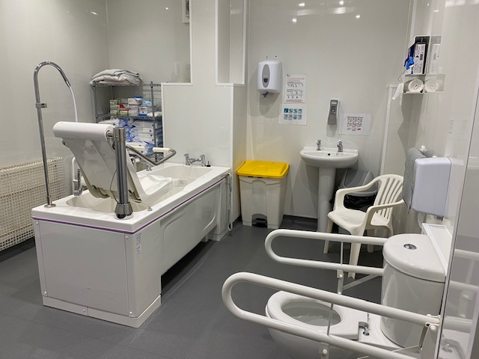

Here is one of the bathrooms in the house we have showers rooms too…

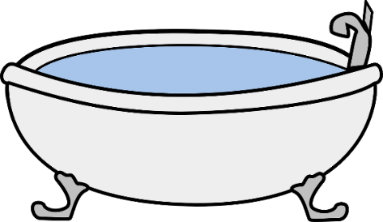



[This Photo](http://www.pngall.com/shower-png) by Unknown Author is licensed under [CC BY-NC](https://creativecommons.org/licenses/by-nc/3.0/)

And this one of our ensuites.

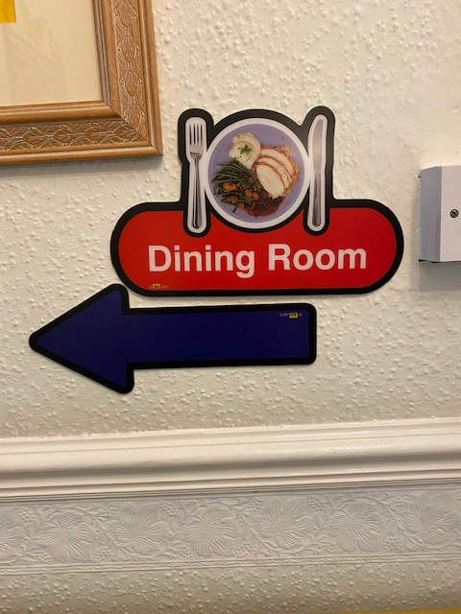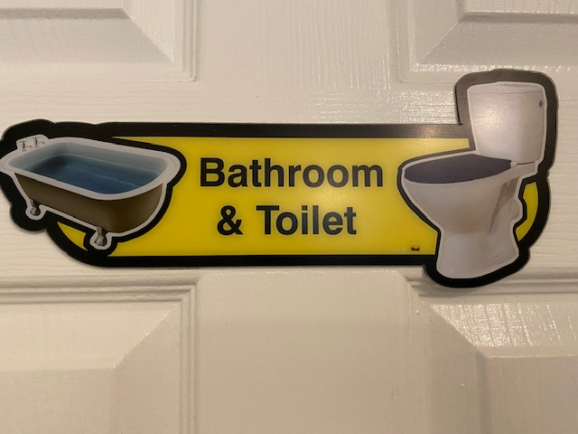

There is lots of signs to help you find you way around.



This is out dining room. You can choose from our menu what you would like for breakfast, lunch and tea.

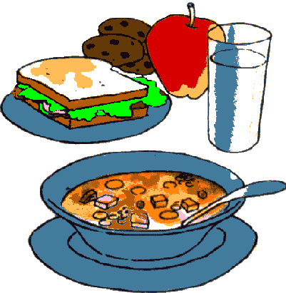



[This Photo](http://pngimg.com/download/38814) by Unknown Author is licensed under [CC BY-NC](https://creativecommons.org/licenses/by-nc/3.0/)

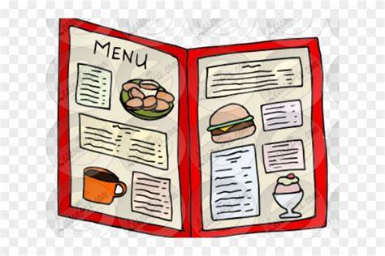

There is a servery where you can make your own drinks.

The dining area was also designed by our clients and is inspired by an American Diner.

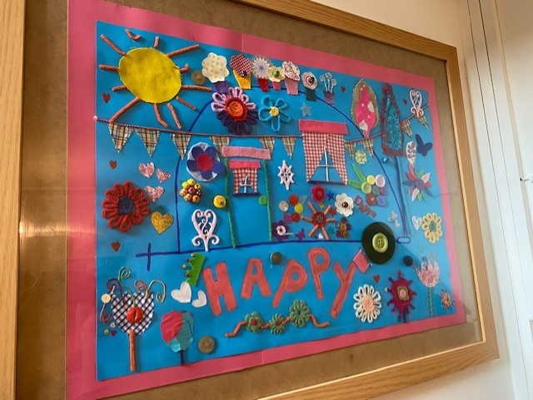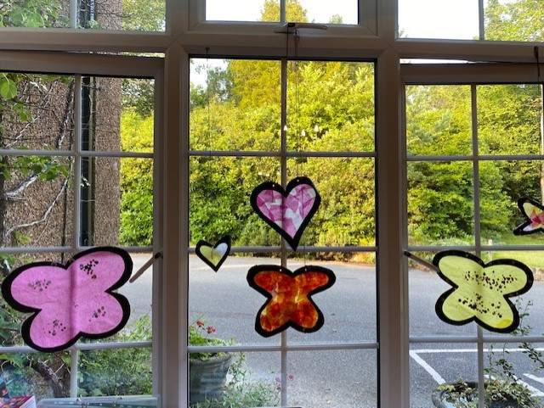

We like to show our work and achievements around Tinkers for all to see.



We have lots for you to do at Tinkers in our Community Hub, where you can create your own timetable and choose the activities you like.

From ball games, art and craft, cooking, musical movement, colouring, puzzles, games, sensory play and much more…..

Or you can just come and watch TV or read a book.

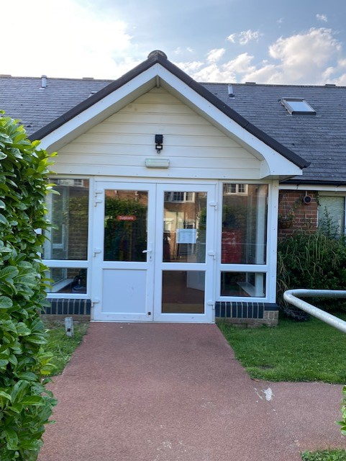





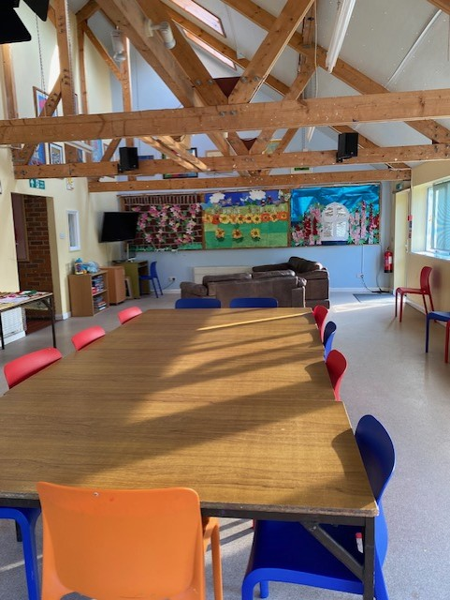

inside the activity centre…. 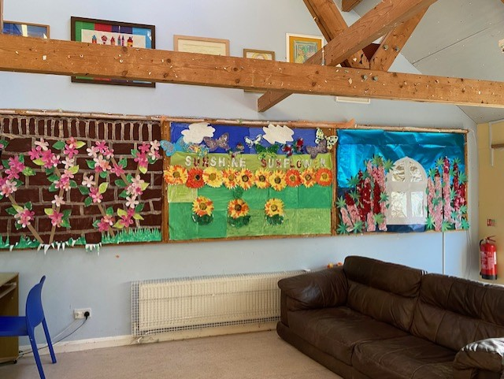

We also like to have parties and get out and about here are some photos of some of the people who live or stay at Tinkers.

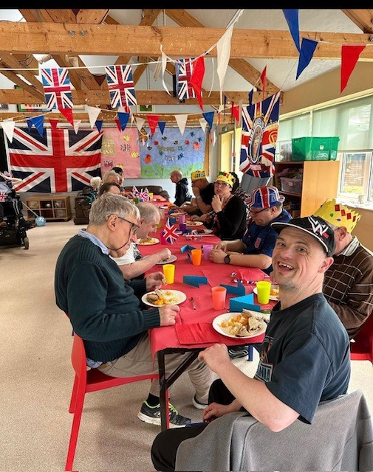

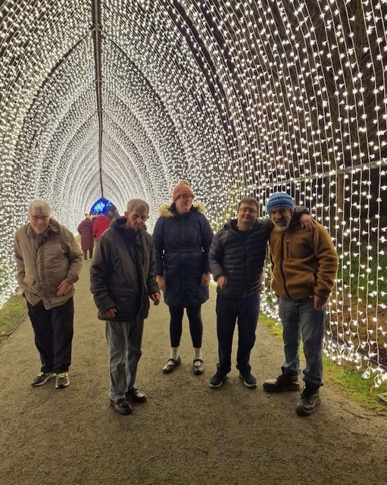 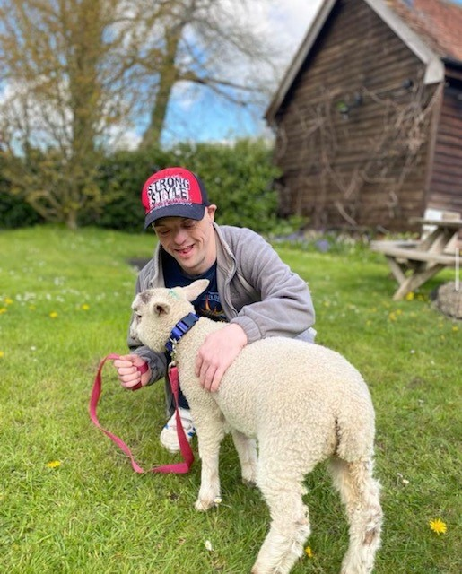

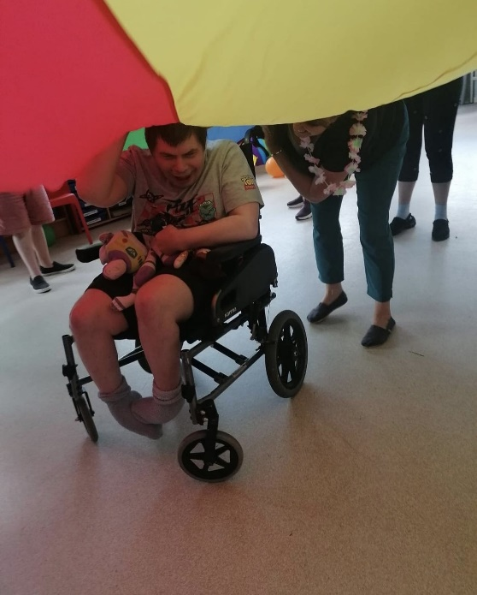

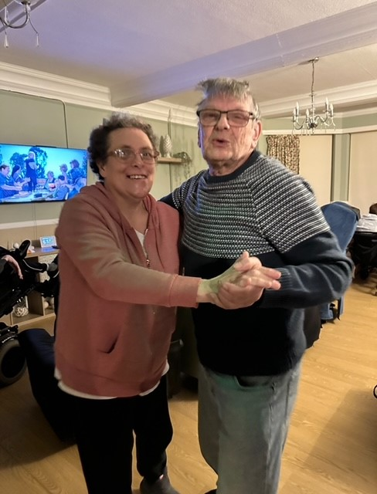

Here are some comments from the people that live and stay at Tinkers.

***‘I am happy, I like being with my friends’.***

***(Scott)***

***I like it here it’s a nice place to live the gardens are nice, I am happy here, I like the staff.***

***(Emma W)***

***It’s a friendly place and activities are good.***

***(Robert)***

***Its nice I like the staff and have made good friends here staff and clients.***

***(Neill W)***

***I like it here because A. I am having my room decorated they way I choose. B. I can go out places I want to go and C. I am happy here.***

***(Neil J)***

***I love it here because it is such a lovely place to live, I would recommend it to anyone. The staff are very good and helpful and kind, and staff are always around to talk to. I love my room and the views and the garden too. My family are happy with me being here too and it has helped me a lot.***

***(Debbie)***

***Its fun, a great place to live, you can always find somewhere quite too if you need to. Helpful staff.***

***(Jennifer)***

***I like the food here and my room. I like the staff.***

***(Pat N)***

***I like coming to tinkers and seeing my friends I like having sleepovers and having a nice bath. Staff are always nice and kind and help me.***

***(Terence)***

***I like living at Tinkers because its nice and I like the staff lots.***

***(Daniel)***

We hope this has helped you please ask if you have any questions?





